LAB EXPERIMENTS
(Class Diagrams)
1. Library Management System
Aim:
To design a Class Diagram representing classes such as Student, Librarian, Book, and Library System and their relationships.
Algorithm:
- Start
- Identify main classes (Student, Librarian, Book).
- Define attributes and methods for each class.
- Establish relationships between classes.
- Create the class diagram.
- Stop.
Input:
Student details, Book details, Issue/Return information.
Output:
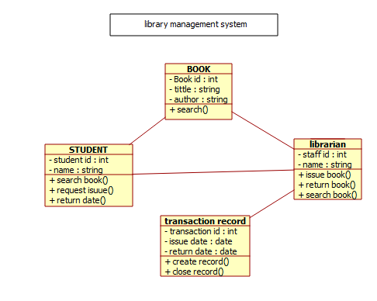
Result:
The Class Diagram represents the structure of the Library Management System with classes and their interactions.
2. Online Shopping / E-Commerce System (Class Diagram)
Aim:
To model classes like User, Vendor, Product, Cart, and Payment in an E-Commerce System.
Algorithm:
- Start
- Identify classes (User, Product, Cart, Vendor, Payment).
- Define attributes and operations.
- Establish relationships between classes.
- Create the class diagram.
- Stop.
Input:
User information, Product details, Order details.
Output:
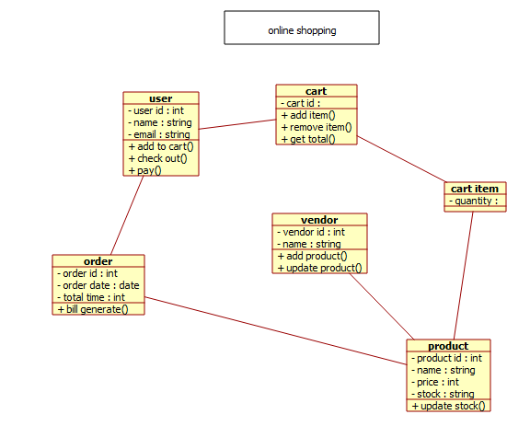
Result:
The Class Diagram illustrates the structure of the E-Commerce System and interactions between User and Vendor.
3. Hospital Management System (Class Diagram)
Aim:
To design a Class Diagram representing Doctor, Patient, Receptionist, and Appointment classes.
Algorithm:
- Start
- Identify system classes.
- Define attributes and methods for each class.
- Establish relationships such as association.
- Draw the class diagram.
- Stop.
Input:
Patient information, Doctor details, Appointment data.
Output:
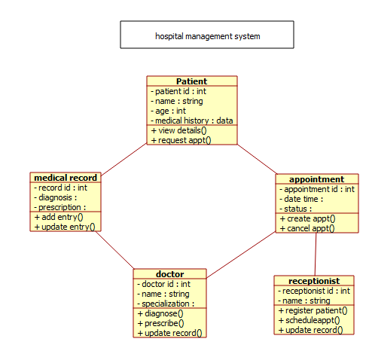
Result:
The Class Diagram shows the relationships between Doctor, Patient, Receptionist, and Hospital System.
4. Railway Reservation System (Class Diagram)
Aim:
To design a Class Diagram representing Passenger, Train, Ticket, and Reservation classes.
Algorithm:
- Start
- Identify major classes in the system.
- Define attributes and operations.
- Establish relationships between classes.
- Construct the class diagram.
- Stop.
Input:
Passenger details, Train information, Reservation details.
Output:
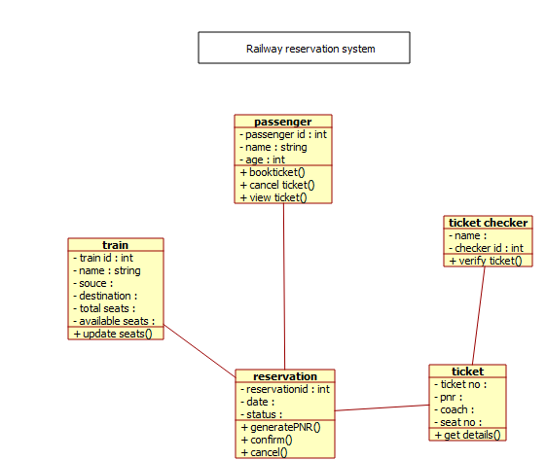
Result:
The Class Diagram represents the structure of the Railway Reservation System.
5. Student Information System (SIS) (Class Diagram)
Aim:
To model classes such as Student, Teacher, Administrator, Course, and Result.
Algorithm:
- Start
- Identify system classes.
- Define attributes and methods.
- Establish relationships among classes.
- Draw the class diagram.
- Stop.
Input:
Student details, Course information, Marks data.
Output:
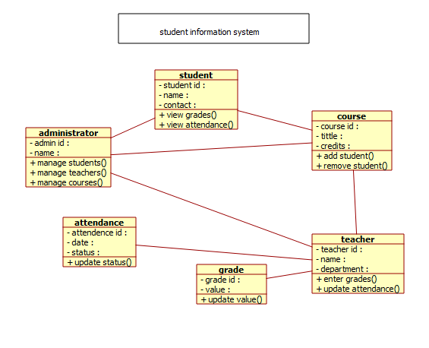
Result:
The Class Diagram shows relationships between Student, Teacher, Administrator, and courses.
6. University Management System (Class Diagram)
Aim:
To design a Class Diagram representing Student, Course, Faculty, and Transcript classes.
Algorithm:
- Start
- Identify main classes.
- Define attributes and methods.
- Establish relationships.
- Construct the class diagram.
- Stop.
Input:
Student registration data, Course details, Grade information.
Output:
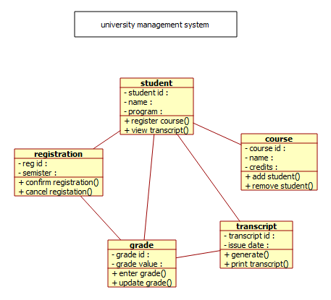
Result:
The Class Diagram shows how Student, Faculty, and Course classes interact in the university system.
7. Employee Payroll System (Class Diagram)
Aim:
To model classes such as Employee, Payroll, Salary, and Department in the Payroll System.
Algorithm:
- Start
- Identify system classes.
- Define attributes and operations.
- Establish relationships between classes.
- Draw the class diagram.
- Stop.
Input:
Employee details, Salary data, Attendance records.
Output:
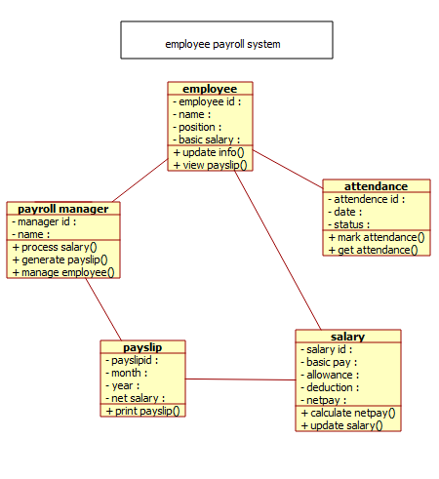
Result:
The Class Diagram shows interactions between Employee, Payroll, and Department classes.

